**Creative Business Document**

**Sustainable Fashion Marketplace**

**Student Name:**

**Student ID:**

**Date:**

**Final Major Project**

Table of Contents

Project Idea: 3

Evaluation Methods: 3

Introduction 4

Our Team: 4

Sustainability Research: 5

Global Presence: 5

Customer Research Questionnaire: 6

Market Research (Primary & Secondary): 6

Company Logo: 8

Final Outcome: Website Plan 8

Reflection 9

References 10

# Project Idea:

Our new online platform, Sustainable Fashion Marketplace, is designed to meet the growing demand for environmentally friendly and ethical fashion. With a strong focus on sustainability and ethical values, our online store has become essential for consumers who shop vyiousdan, navigating between fast fashion and ethical textiles. Our core concern is a range of fashion brands that are responsible for environmental protection, fair labor and community well-being.

Our platform bridges the gap between quality consumers and brands that embrace ethical manufacturing. By artistically showcasing eco-friendly clothing, footwear and beauty products, we help customers make responsible choices that meet their needs. Whether it's ethically produced textiles or animal free skin care, every product goes through rigorous testing to meet our sustainability standards.

Through our sustainable fashion marketplace, we aim to bring together people from all walks of life who appreciate and promote ecological sustainability in the fashion industry. We strive to achieve this by supporting brands that emphasize sustainability, and hope the industry becomes a compassionate and creative culture. We invite you to join us for this innovative transformation as we redefine fashion through sustainability, style and social responsibility.

In terms of preliminary research, we plan a survey and interview with potential users and industry experts to collect information about their preferences, problems and expectations about sustainable fashion. This will help us customize our platform to effectively meet the needs of our target audience. We will also report existing data on sustainable fashion trends and consumer behavior as part of secondary research to inform our strategies and decisions.

The final result of our project will be the design and development of a comprehensive website that provides a user-friendly interface for browsing and purchasing sustainable fashion products.

# Evaluation Methods:

To evaluate the success of our project, we will use several methods aimed at evaluating different aspects of our work and ensure its inclusiveness. This evaluation will include primary and secondary research methods, as well as ongoing feedback mechanisms to inform our decision-making and project monitoring.

1. Brand Partnerships: We will measure the number of brands supporting ethical sourcing on our platform through surveys and interviews with potential partners, as well as asking industry experts for feedback. In addition, we will consult with faculty and colleagues to brainstorm potential brand partnerships.
2. Customer Growth: We will track metrics such as monthly active users, repeat purchases, and customer satisfaction through research and analytics tools. This insight will help us better understand our customers' wants and needs and adjust our strategy accordingly. We will also ensure inclusivity by soliciting feedback from various customers and stakeholders.
3. Sustainability Impact: To assess the sustainability impact of our platform, we will monitor metrics such as the reduction of fast fashion shopping by our customers as shown by research and data analysis. We will also gather insights from our faculty and colleagues on how to improve the sustainability aspects of our work.
4. Revenue Growth: Sales commission revenue growth from brands on the platform will be a key indicator of the financial success of our business. We will analyze sales data and conduct financial assessments to track revenue growth over time. In addition, we will seek input from faculty and colleagues on strategies to increase revenue by ensuring the inclusiveness of our work, such as hiring diverse people and creating a supportive work environment.

From an inclusive perspective, we are committed to creating a diverse and inclusive work environment by implementing policies and practices that promote diversity, equity and inclusion. This includes actively recruiting and hiring employees at different levels, providing equal opportunities for professional growth and development, and fostering a culture of respect and inclusion within the organization. We will also solicit input from faculty, colleagues, and other stakeholders to ensure that our business practices reflect the communities we cover and serve.

# Introduction

Personal Skills:

* I will actively seek opportunities for professional development in areas such as marketing, business management and sustainability practices to improve my skills and effectively contribute to business development.
* I will be networking with industry experts, attending seminars and constantly learning to stay up-to-date with the latest trends and practices in fashion and business management.

Mission:

Our goal is to transform the fashion industry by promoting sustainable and ethical practices while offering stylish and eco-friendly alternatives. We aim to empower people to make choices that are in line with the values of environmental protection and social responsibility.

Business Goals:

* Establish partnerships with at least 20 sustainable fashion brands in the first year of operation.
* Increased monthly active users on the platform by 50% in the first six months.
* In the first year, we expanded our product range to include accessories and home products made from sustainable materials.
* Implement a comprehensive marketing strategy to increase awareness of our platform and attract a diverse customer base.
* Achieved profitability in the first two years of operations through strategic pricing and revenue generation initiatives.

Income:

* Our business will generate revenue primarily through sales commissions from partner brands listed on the platform.
* We will also explore additional revenue streams such as sponsored content, subscription services and affiliate marketing partnerships.
* Implement a tiered pricing model for premium features and services offered to customers and brands.
* Offer unique promotional packages for brands looking to promote their sustainable products to our target audience.

# Our Team:

* **Founder & CEO:** In charge of checkout process, stock management and delivery, customer service.
* **Marketing Director:** Managing marketing campaign and user acquiring process.
* **Web Developer:** Processes like developing and running the Sustainable Fashion Marketplace platform.
* **Sustainability Analyst:** Researching brands and making sure of ethical and sustainable conduct.

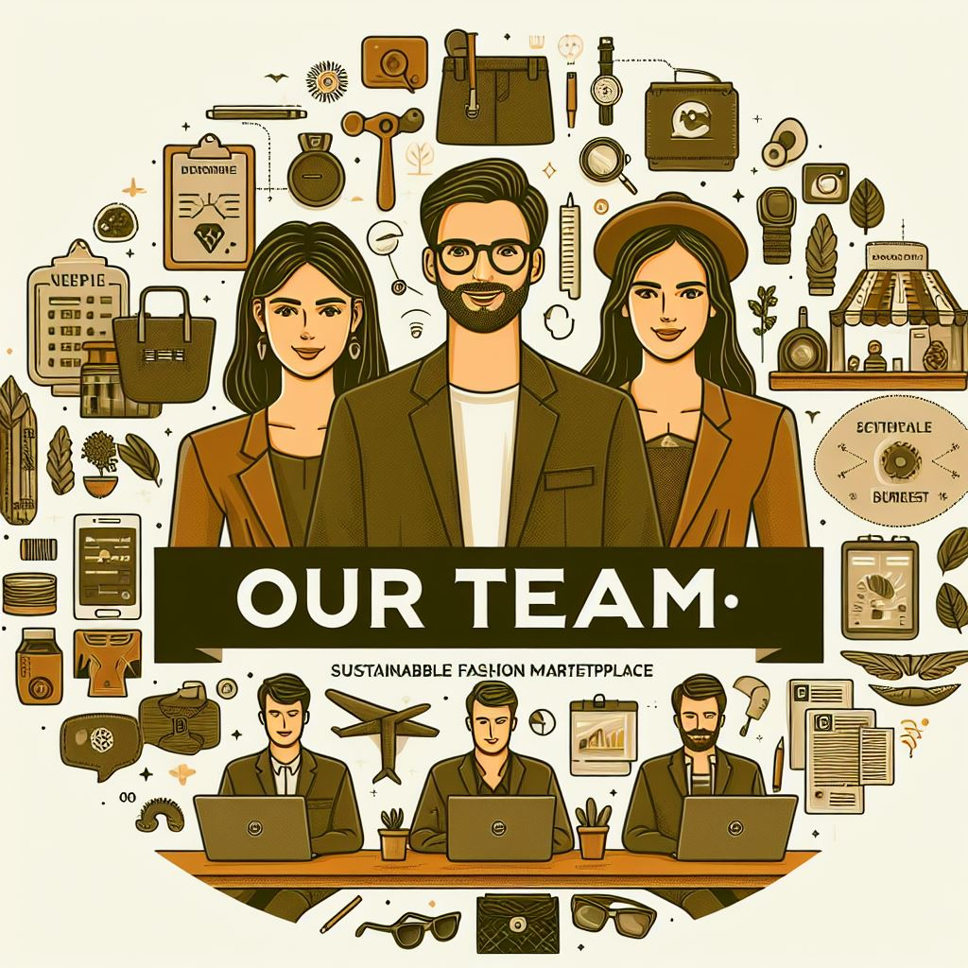

# Sustainability Research:

The fashion industry is one of the largest polluters as almost every aspect of this industry deals with environmental concerns such as climate change and textile waste. The Sustainable Fashion Marketplace works intensely to amplify the sustainable operations at all points of a fashion value chain. We will develop partnership with those brands that has the following priorities:

* **Ethical Labor:** Fair pay, safe job settings as well as no forced child labor.
* **Eco-Friendly Materials:** Cotton made from organic fibers, recycled materials, and low-impact dyes.
* **Reduced Waste:** At the production stage, we ensure that we develop processes that do not waste water.
* **Transparency:** Brands that are openly expressing their efforts for sustainability.

In line with the UN Sustainable Development Goals (SDGs), the Sustainable Fashion Market will focus on the following three goals:

Goal 8: Decent work and economic development

Our project contributes to this goal by prioritizing partnerships with brands that support ethical labor practices, such as fair wages, safe working conditions, and the elimination of child labor. By supporting this brand, we aim to promote decent job opportunities and economic growth in the fashion industry while ensuring the well-being of workers in the supply chain.

Goal 12: Responsible consumption and production

A sustainable fashion market addresses Goal 12 by promoting environmentally friendly materials and reducing waste in the fashion value chain. We prefer to work with brands that use organic fibers, recycled materials and low impact paints in their manufacturing process. We also work with brands that implement sustainable practices to reduce water waste and environmental pollution, thereby improving our consumption and production practices.

Objective 13: Air Traffic

With a focus on sustainability and transparency, the Sustainable Fashion Market supports Goal 13 by encouraging brands to be transparent about their sustainability efforts. By partnering with brands that prioritize environmentally friendly practices and reduce their carbon footprint, we contribute to reducing climate change and promoting climate action in the fashion industry. Our platform serves as a catalyst to raise awareness of the environmental impact of the fashion industry and help consumers make eco-conscious purchasing decisions.

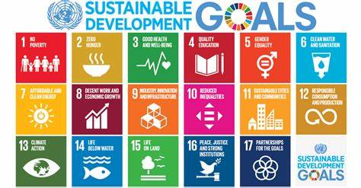

# Global Presence:

Our sustainable fashion marketplace will focus on following 3 key markets:

* **North America:** In addition to a huge market, there is a rapid consumer awareness growth for sustainable fashion.
* **Europe:** A leader in regulation of the eco-fashion industry together with the consumer's demand for a greener use of fabrics.
* **Southeast Asia:** A vivid and emerging fashion market that has sustainable and ethical production as an opportunity.

# Customer Research Questionnaire:

* What role do you, as a consumer, attribute to sustainability in relation to the process of clothing shopping? (Extremely/Little/Middle/Moderate/Not and barely)
* What are the most formidable difficulties that you come against in the process of shopping for eco-friendly clothing? (For instance, limited product choice/High price range/Lack of reliable brands/Something else)
* What specifications are the most essential in an online sustainable fashion market? (BDI brand sustainability ratings/Product information on environmental impact/Edited eco-fashion collections)
* What is the typical amount of money you allocate for clothing purchases?
* Do you prefer classic or modern patterns, delicate or bold designs?
* Are you ready to be a customer to pay little more for apparel made with environmentally friendly practices? (Yes/No)

# Market Research (Primary & Secondary):

**Primary Research:**

* **Customer surveys:** We will take surveys to be able to have a clear understanding of the market situation related to sustainable fashion.

**Secondary Research:**

* **Industry reports:** In-depth analysis of the industry reports provided a great amount of relevant data on the scale of the global sustainable fashion market featuring its size, expected growth perspectives, and recent fashion trends. This is what guided us onward, in our strategic making and market placement.
* **Competitor analysis:** The competitive advantages and the differentiation areas were identified through a comprehensive analysis of both sustainable fashion marketplaces and goods on the world market. In order to unveil competitors' advantages and disadvantages we worked up tactical approaches to render distinct values for our audience.

**4P's of Marketing:**

* **Product:** An ethical and sustainable fashion, footwear, beauty goods selection which we hand-selected for you.
* **Price:** We will be in collaboration with brands which are both affordable and from high-end costs this is to be able to serve all customers regardless of the amount they spend while maintaining fair prices for producers.
* **Place:** The Sustainable Fashion Online Marketplace will be a user-friendly website and mobile app, available for online shopping.
* **Promotion:** Among our marketing strategies, we will engage in social media, influencer partnerships, and content creation to disseminate knowledge of sustainable fashion and to publicize the platform.

# Company Logo:

We have designed a logo and attached it below:

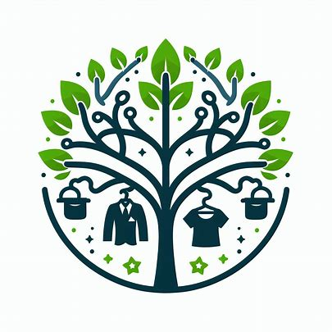

# Final Outcome: Website Plan

The website will be our main communication tool for customers, and the customers will be our target users. Key features will include:

* An interface, which is user-friendly with filters like shop by brand, price, style, and sustainability.
* Product descriptions that explain the material, production method and environmental implications in complete detail.
* Education resources such as sustainable fashion and ethical consumption as wealth creating strategies.
* We implement a strong payment gateway and also a seamless order fulfillment system.
* Interactive community attributes can be expressed through customer reviews and curated fashion selections.

# Reflection

Sustainable fashion business is an exciting as well as a challenging journey. Therefore, it gave me an opportunity to utilize my knowledge of marketing and business in a campaign dealing with just a cause I'm enthusiastic about.

This experience will boost my skills in research and analysis, predominantly when I was analyzing the market trends and those of the competitors. Additionally, I will sharpen myself in communications domain through tailored marketing messages and a site plan that is user-friendly.

I will like to be more well-versed in project management in order to guarantee that the marketplace's launch and daily runs are done as efficiently as possible. Besides learning new knowledge about sustainable fashion manufacturing procedures to bolster educational aspects of the platform. This detailed awareness will give the ability to link with brands and consumers in a more personalized and effective way which in turn will lead to more relevant and successful business.

# References

CookieBot, 2023. *How to build a marketplace for sustainable fashion.* [Online]   
Available at: https://www.sharetribe.com/create/how-to-build-marketplace-for-sustainable-fashion/

Ryzhkov, A., 2023. *Boost Your Sustainable Fashion Marketplace Profitability.* [Online]   
Available at: https://finmodelslab.com/blogs/profitability/online-sustainable-fashion-marketplace-profitability

Trends, G. S. a., 2024. *Sustainable Fashion Market Size, Growth & Forecast Report.* [Online]   
Available at: https://www.linkedin.com/pulse/sustainable-fashion-market-size-growth-forecast-rmfje/

Worldfirst, n.d. *A marketplace seller’s guide to sustainable fashion.* [Online]   
Available at: https://www.worldfirst.com/uk/marketplace-sellers/e-commerce-guides/what-is-sustainable-fashion-a-market-place-sellers-guide/